**NuageCX**

**Business Requirements Documents (BRD)**

For

Implementation of

"City Transport Ticketing and Real-Time Bus Tracking Application”

16/01/2024

**Revision History**

|  |  |  |  |
| --- | --- | --- | --- |
| **Date Version Author Change** | | | |
| 16/01/2024 | 1 | Apaar Jain | 1st Draft |
|  |  |  |  |
|  |  |  |  |
|  |  |  |  |

**Contributors To The Document**

| **Name** | **Role** | **Department** | **Responsibility** |
| --- | --- | --- | --- |
| John Doe | Project Manager | Product Development Department | Overseeing project progress and ensuring alignment with business requirements. |
| Apaar Jain | Business Analyst | Business Analysis Department | Conducted analysis and collaborated with the client to capture business needs. |
| Amit Kumar | Technical Architect | Technology Department | Defined technical approach and system architecture for scalability and performance. |
| Priya Deshmukh | UI/UX Designer | Design Department | Designed the user interface and ensured a user-friendly experience. |
| Rajesh Mehta | QA Lead | Quality Assurance Department | Developed test plans and ensured the application met functional requirements. |
| Neha Joshi | Client Relationship Manager | Client Services Department | Liaised with PMC to capture and align business needs with the solution. |
| Vikram Singh | Operations Manager | Operations Department | Provided input on operational integration and alignment with Pune’s transport system. |

**Table Of Contents**

**1.** **Introduction** 5

1.1 Purpose 5

1.2 Document Management 5

Document Storage: 6

Document Distribution: 6

Revision Control: 6

1.3 Organizational Areas Affected 6

1.4 Reason For Project and Project Methodology 7

Reason for the Project 7

Project Methodology 8

**2.** **Overview** 9

2.1 Business Purpose 9

2.2 Measure of Success 9

2.3 Project Priorities 10

**3.** **Project Diagrams** 11

3.1 Business Process Flow Diagram (BPNM) 11

3.2 Use-Case Diagram 12

3.3 System-Architecture Design 13

3.4 Data Flow Diagram (DFD) 14

3.5 Entity Relationship Diagram (ERD) 15

3.6 Wireframes or Mockups 16

3.7 Stakeholder Map or RACI Diagram 17

3.8 Gantt Chart or Timeline 18

3.9 Swimlane Diagram 19

**4.** **Assumptions/Constraints/Risks/Dependencies** 20

4.1 Assumptions 20

4.2 Constraints 20

4.3 Risks 21

4.4 Dependencies 22

**5.** **Statement of Business Requirements** 23

5.1 Background 23

5.2 Current Environment 23

5.3 Challenges in the Current System 23

5.4 Opportunity for Improvement 24

5.5 Impact on System or Processes 24

**6.** **Business Process** 26

6.1 Current Business Flow 26

6.2 New-Process 27

**7.** **System Requirements** 29

**8. Other Options To Satisfy The Requirements** 32

**9.** **Definition Of Completion** 36

**10.** **User Stories Summary** 36

**11.** **Impact Urgency** 39

**12.** **Approvals** 42

# **Introduction**

This Business Requirements Document (BRD) outlines the business needs and objectives for the development and implementation of a mobile application for Pune Municipal Corporation (PMC). The application aims to enhance the city’s public transportation system by enabling users to book tickets for local buses seamlessly, track real-time bus locations, and receive live, valid digital tickets for easy access and validation during travel.

The purpose of this document is to clearly define the requirements and expectations from PMC to ensure that the solution meets the needs of both the commuters and the transport service providers. It serves as a foundation for the design, development, and deployment phases, ensuring that the project aligns with the city's strategic goals for improving public transportation accessibility, efficiency, and user experience.

This BRD provides a detailed overview of the business objectives, key functionalities, and deliverables expected from the mobile application, with a focus on creating a reliable, user-friendly solution that fosters trust and adoption among the residents of Pune.

## 1.1 Purpose

The purpose of this Business Requirements Document (BRD) is to outline the business needs and objectives for the development and implementation of a mobile application to facilitate seamless ticket booking and real-time bus tracking for Pune Municipal Corporation (PMC). This document aims to serve as a clear and comprehensive guide for both PMC and the development team, ensuring that all business requirements are properly captured, understood, and addressed throughout the project lifecycle.

The BRD will define the functional and non-functional requirements, scope, constraints, and deliverables associated with the mobile application. It will serve as a reference point to ensure the final product aligns with PMC's goals of improving public transportation services, enhancing user experience, and ensuring operational efficiency.

By establishing a common understanding between all stakeholders, this document will ensure the successful development and deployment of a solution that meets the needs of PMC and its citizens.

## 1.2 Document Management

The Document Management section defines how the Business Requirements Document (BRD) will be maintained, updated, and tracked throughout the project lifecycle. It ensures that the document remains accurate, accessible, and relevant to all stakeholders.

### Document Storage:

The BRD and related documents will be stored in a centralized project repository accessible to all authorized stakeholders. The repository will be organized in folders by version, with clear version control to ensure the latest version is always in use.

### Document Distribution:

* Pune Municipal Corporation (PMC) management team
* Development and design teams
* Quality Assurance (QA) team
* Operations team

### Revision Control:

Any revisions to the BRD must be clearly documented, including the version number, date of the revision, a description of the changes, and the names of the individuals responsible for the changes. Each version of the BRD will be subject to review and approval by PMC's project sponsor before being finalized.

## 1.3 Organizational Areas Affected

1. **Public Transportation Department**

* The department will be directly impacted as the mobile application aims to improve public transportation services. It will need to collaborate with the development team to ensure integration with existing transportation systems and processes.

1. **IT and Technology Department**

* The IT department will play a critical role in supporting the technical aspects of the application, including hosting, security, and maintenance. They will work with the technical team to ensure the app is scalable, secure, and integrates seamlessly with PMC’s existing infrastructure.

1. **Customer Service Department**

* The customer service team will be impacted as the mobile application introduces a new channel for ticket booking and customer support. They will need to be trained to handle user inquiries related to the app, ticket validation, and real-time bus tracking issues.

1. **Operations Department**

* The operations team will need to ensure that the mobile application integrates effectively with real-time tracking data, bus schedules, and other operational processes. They will also help manage the rollout and user adoption of the app.

1. **Marketing and Communications Department**

* The marketing team will be responsible for promoting the new mobile app to commuters and the general public. They will create communication materials and campaigns to increase awareness and drive app downloads.

1. **Finance Department**

* The finance team will be involved in setting up and monitoring payment processing for ticket bookings within the app. They will also be responsible for ensuring that financial transactions and revenue generation through the app are accurate and compliant with organizational policies.

1. **Legal and Compliance Department**

* Legal and compliance teams will ensure that the mobile app meets all regulatory requirements, including data protection laws, financial regulations, and any legal considerations related to ticketing and payment processing.

1. **Human Resources Department**

* HR will play a role in training staff members, particularly those in customer service and operations, on how to effectively use and support the mobile application. Additionally, HR may be involved in recruiting specialized roles if needed.

1. **Project Management Office (PMO)**

* The PMO will oversee the project’s execution, ensuring it stays on track, on budget, and within scope. They will monitor progress, mitigate risks, and ensure proper reporting to key stakeholders.

1. **External Partners (e.g., Payment Gateway Providers, Third-Party Vendors)**

* External partners will be engaged for payment processing, data services, or any other third-party integrations required to ensure the app’s functionality and user experience.

## 1.4 Reason For Project and Project Methodology

### **Reason for the Project**

The primary reason for this project is to enhance the public transportation experience in Pune by developing a user-friendly, efficient mobile application that allows citizens to seamlessly book tickets for local city buses and track buses in real-time. Pune Municipal Corporation (PMC) seeks to improve the accessibility, convenience, and reliability of its public transportation services. This mobile application aims to address the following key challenges:

1. **Ease of Ticketing**: The mobile app will provide an easy-to-use platform for commuters to purchase tickets online, reducing the reliance on manual ticket sales and long queues at bus stations.
2. **Real-time Bus Tracking**: By providing real-time bus location data, the app will allow passengers to track buses along their routes, improving user confidence in the punctuality and reliability of the transportation system.
3. **Digital Validation**: The live, valid ticket with a green validation symbol will simplify the ticket verification process, streamlining operations for bus conductors and reducing fare evasion.
4. **Environmental Impact**: By promoting digital ticketing, the project will contribute to reducing paper waste and promoting sustainability in the city's public transport system.
5. **Operational Efficiency**: The project will help PMC optimize ticketing operations and gather valuable insights through data analytics to improve bus routes, schedules, and overall service.

The success of this project will not only modernize the city's public transport system but also contribute to enhanced commuter satisfaction and improved operational efficiency for Pune Municipal Corporation.

### **Project Methodology**

The development of the mobile application for PMC will follow an **Agile project methodology** to ensure flexibility, collaboration, and iterative progress. The Agile approach will allow for continuous feedback from PMC stakeholders and end users, enabling the development team to adapt to evolving requirements and deliver incremental improvements. The key phases of the project will include:

1. **Initiation & Planning**
   * During this phase, project objectives, scope, timelines, and key deliverables will be defined. Initial requirements will be gathered from PMC and stakeholders to establish the foundation for the project.
2. **Requirements Gathering & Analysis**
   * Detailed business requirements will be documented, with collaboration between business analysts, stakeholders, and technical teams to ensure all functional and non-functional needs are understood.
3. **Design & Prototyping**
   * User interface (UI) and user experience (UX) design will be created based on the requirements gathered. Prototypes will be developed for early user feedback, ensuring that the app is intuitive and user-friendly.
4. **Development (Sprints)**
   * The development process will be broken down into multiple short cycles or "sprints." Each sprint will focus on developing specific features and functionality, with each sprint ending in a deliverable product that can be tested and reviewed by stakeholders.
5. **Testing**
   * After each sprint, thorough testing (unit, integration, user acceptance) will be conducted to ensure the app meets business and technical requirements. Continuous feedback will be incorporated into subsequent development phases.
6. **Deployment & Implementation**
   * After successful testing and feedback incorporation, the application will be deployed in the live environment. A phased rollout may be considered to ensure smooth adoption.
7. **Post-Deployment Support & Maintenance**
   * Following deployment, ongoing support and maintenance will be provided to address any issues, perform updates, and ensure continued optimal performance of the mobile application.

# **Overview**

## **2.1 Business Purpose**

The business purpose of this project is to provide Pune Municipal Corporation (PMC) with a modern, user-friendly mobile application that enhances the public transportation experience for commuters and streamlines bus operations. The primary goals of the project are:

1. **Improved Customer Experience**: By enabling easy online ticket booking, real-time bus tracking, and digital ticket validation, the app will increase commuter convenience and satisfaction.
2. **Operational Efficiency**: The app will reduce manual ticketing efforts, minimize queues, and enhance the ability of bus conductors to validate tickets quickly, leading to smoother bus operations and reduced fare evasion.
3. **Increased Accessibility**: The mobile application will cater to a larger audience by offering an accessible, easy-to-use solution for a wide range of users, including people with varying levels of tech proficiency.
4. **Data-Driven Decision Making**: By collecting data on user behavior, ticketing patterns, and bus performance, PMC will be able to make informed decisions to optimize routes, schedules, and service delivery.
5. **Sustainability**: The project will reduce the reliance on paper tickets, contributing to environmental sustainability by lowering the use of physical materials.

## **2.2 Measure of Success**

The success of the project will be measured through the following key performance indicators (KPIs):

1. **User Adoption and Engagement**
   * Target: Achieve X number of app downloads and Y% active users within the first three months of launch.
   * Measure: Monitor app downloads, daily active users (DAU), and weekly active users (WAU) through analytics tools.
2. **Ticket Sales and Revenue Generation**
   * Target: Increase the percentage of online ticket bookings by Z% within the first six months.
   * Measure: Track the volume of digital tickets sold compared to traditional manual tickets.
3. **Real-time Bus Tracking Accuracy**
   * Target: Achieve an accuracy rate of 95% for real-time bus location tracking.
   * Measure: Regularly evaluate the accuracy and timeliness of the bus tracking data provided by the app.
4. **Customer Satisfaction**
   * Target: Achieve a customer satisfaction score (e.g., through surveys or app reviews) of 4.5 stars or above.
   * Measure: Collect feedback from users through in-app surveys, customer support tickets, and app store ratings.
5. **Operational Efficiency**
   * Target: Reduce the average time spent by bus conductors in ticket validation by X%.
   * Measure: Track the time spent per ticket verification and compare it to pre-implementation metrics.
6. **System Reliability and Performance**
   * Target: Maintain an app uptime of 99.9% or higher.
   * Measure: Track system uptime, response times, and incident reports post-deployment.

## **2.3 Project Priorities**

The following project priorities will guide the development and implementation of the mobile application:

1. **User Experience (UX) and Interface (UI) Design**
   * Priority: The app must have an intuitive, easy-to-navigate interface that provides a seamless user experience across different devices (smartphones, tablets).
   * Focus: Simplicity, accessibility, and responsiveness will be paramount to ensuring high adoption rates among users.
2. **Real-time Bus Tracking Functionality**
   * Priority: The app must offer accurate, real-time bus location tracking to enhance user trust and enable better journey planning.
   * Focus: Integration with existing tracking systems and ensuring accuracy and timely updates.
3. **Digital Ticketing and Validation**
   * Priority: The app should provide a secure, reliable ticketing system with a live, valid ticket that is easily validated by bus conductors.
   * Focus: Smooth integration with the bus validation system and preventing fare evasion.
4. **Scalability and Performance**
   * Priority: The app must be able to handle high traffic volumes, especially during peak hours, and scale as the user base grows.
   * Focus: Ensuring that the app’s infrastructure is robust and capable of supporting large numbers of concurrent users.
5. **Data Security and Compliance**
   * Priority: The app must meet all security and compliance standards, including user data protection and payment security.
   * Focus: Incorporating strong encryption protocols, secure payment gateways, and compliance with data protection regulations (such as GDPR).
6. **Post-Launch Support and Maintenance**
   * Priority: Ensuring continued app performance with ongoing bug fixes, updates, and customer support after launch.
   * Focus: A strong support and maintenance plan for troubleshooting and feature enhancements based on user feedback.

# **Project Diagrams**

## 3.1 Business Process Flow Diagram (BPNM)

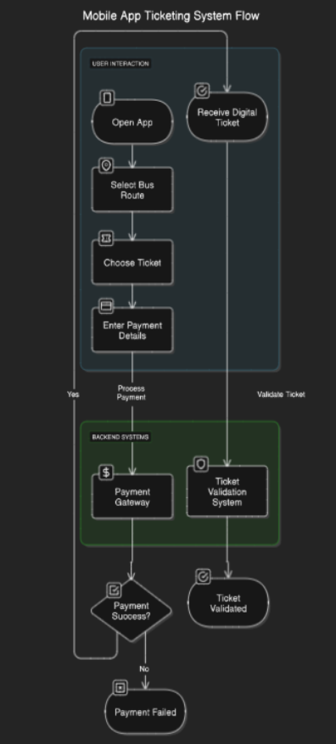

## 3.2 Use-Case Diagram

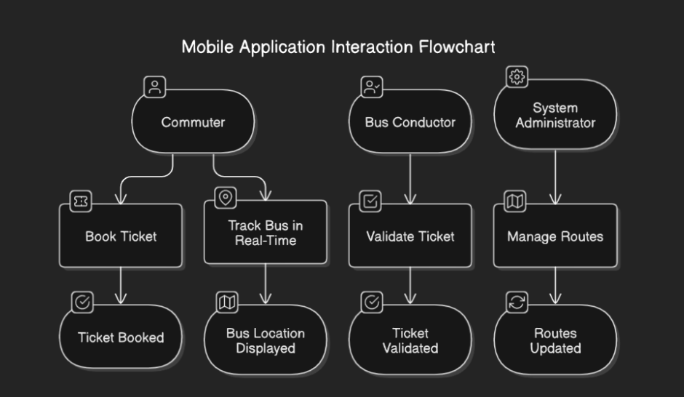

## 3.3 System-Architecture Design

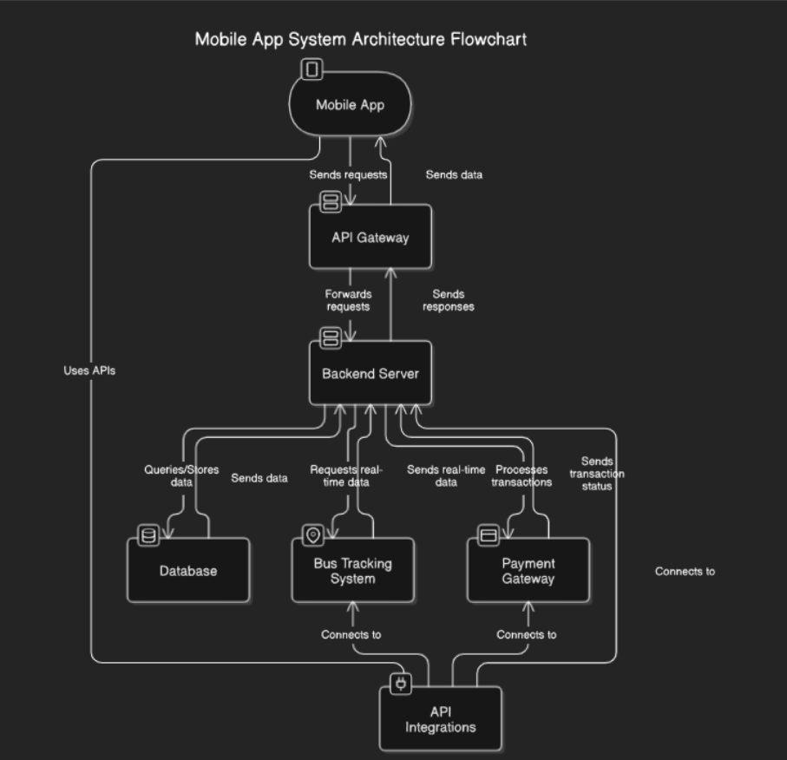

## 3.4 Data Flow Diagram (DFD)

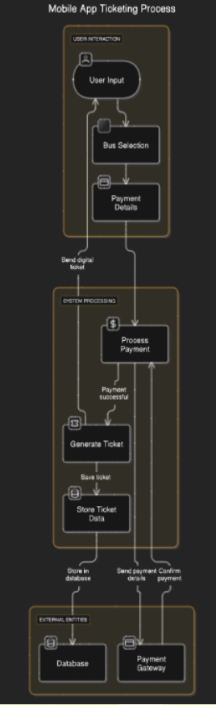

## 3.5 Entity Relationship Diagram (ERD)

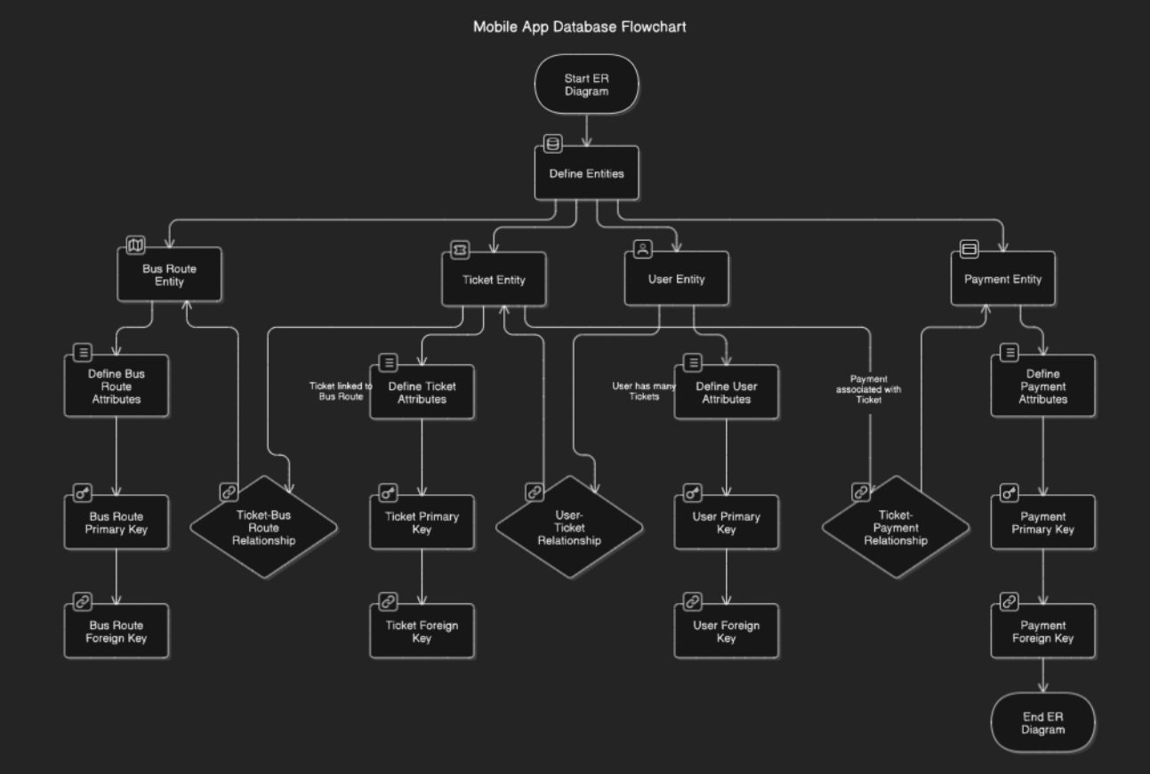

## 3.6 Wireframes or Mockups

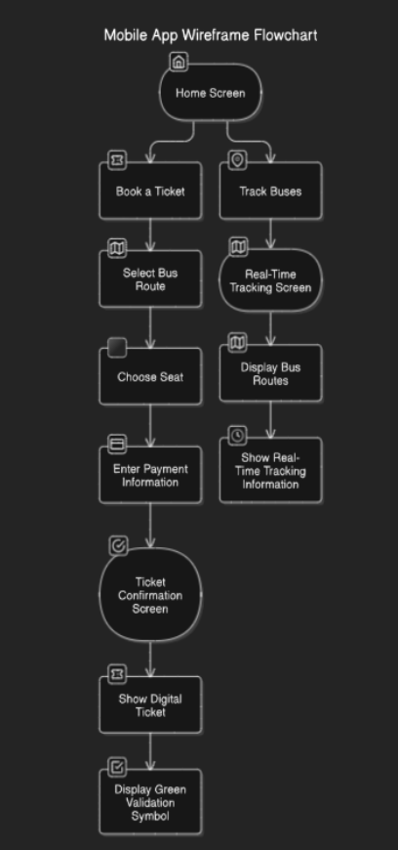

## 3.7 Stakeholder Map or RACI Diagram

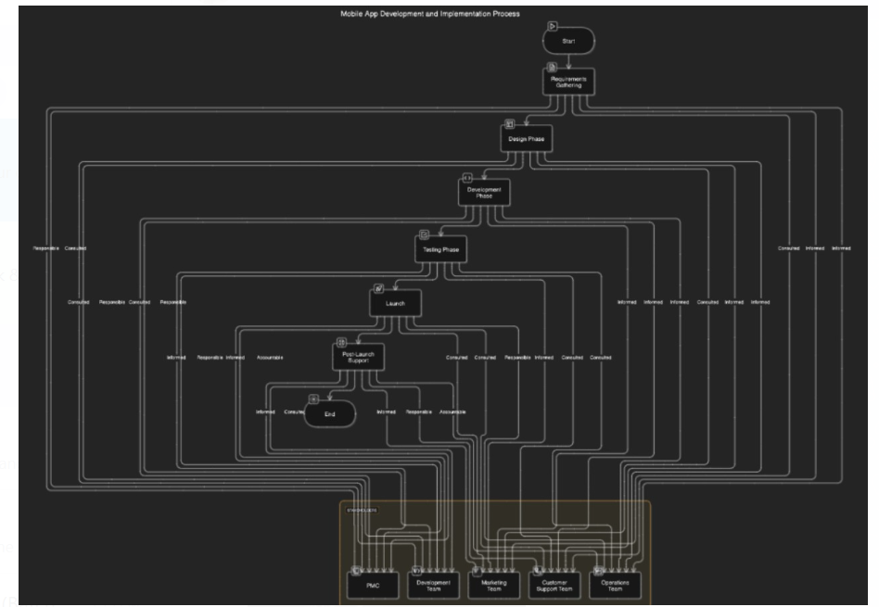

## 3.8 Gantt Chart or Timeline

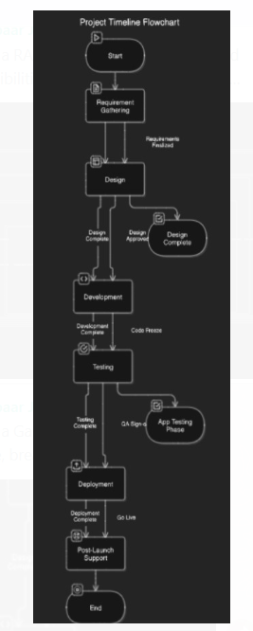

## 3.9 Swimlane Diagram

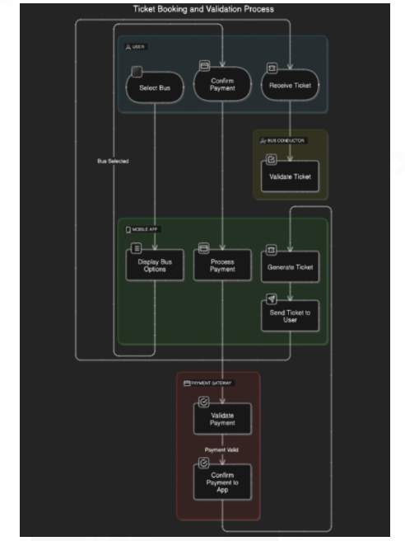

# **Assumptions/Constraints/Risks/Dependencies**

## **4.1 Assumptions**

The following assumptions have been made during the planning and development of the mobile application for Pune Municipal Corporation (PMC):

1. **User Access to Smartphones**: It is assumed that a significant portion of the commuting population in Pune has access to smartphones and is comfortable using mobile apps.
2. **Internet Connectivity**: It is assumed that users will have reliable internet access (3G/4G/5G or Wi-Fi) while booking tickets and tracking buses in real-time.
3. **Real-time Bus Data Availability**: The project assumes that PMC has the necessary infrastructure and data feeds to provide accurate and real-time bus tracking data through integration with the existing bus management systems.
4. **Payment Gateway Integration**: It is assumed that PMC has an existing partnership with a reliable, secure payment gateway provider, and the integration will be smooth.
5. **Sufficient Budget and Resources**: It is assumed that PMC will provide the required budget, resources, and collaboration from all relevant departments (e.g., IT, Operations, Customer Support) for the successful implementation of the app.
6. **Compliance with Regulations**: The project assumes that the app will comply with relevant local laws and regulations (e.g., data privacy laws, financial regulations for transactions) and that legal requirements will be met.

## **4.2 Constraints**

The following constraints have been identified for the mobile application project:

1. **Limited User Base for Initial Launch**: The initial launch may be limited to specific bus routes or geographic areas in Pune, affecting the scope of app adoption in the early stages.
2. **Integration with Existing Systems**: The app’s ability to provide real-time bus tracking and validate tickets depends on seamless integration with PMC’s existing infrastructure, which may have technical limitations or require custom solutions.
3. **Device Compatibility**: The mobile app must be compatible with a wide range of smartphones, including both Android and iOS platforms. Variations in device specifications, operating systems, or software versions could limit functionality or require additional testing.
4. **Regulatory Compliance**: The app must meet data privacy regulations (e.g., GDPR or India’s data protection laws) and payment gateway security requirements, which could create constraints around data storage, sharing, and processing.
5. **Operational Constraints**: There may be operational challenges in training bus conductors and customer service teams to use the new system for ticket validation and issue resolution.
6. **Budget and Time Limitations**: The development of the mobile application is constrained by both the project’s budget and timeline. These factors may limit the scope of features in the initial release or delay the development of certain functionalities.

## **4.3 Risks**

The following risks have been identified that could impact the project’s success:

1. **Technical Integration Risks**:
   * **Risk**: Difficulties in integrating the mobile app with existing PMC systems (such as bus tracking or payment gateways) could lead to delays or functionality issues.
   * **Mitigation**: Conduct thorough technical assessments during the planning phase, and ensure the development team has access to relevant APIs and system documentation.
2. **User Adoption and Engagement**:
   * **Risk**: Low adoption rates among commuters or challenges in encouraging users to download and actively use the app could result in limited success.
   * **Mitigation**: Develop a strong marketing campaign, including user incentives, and engage with local communities to raise awareness. Offer user training materials and provide customer support.
3. **Data Security and Privacy Concerns**:
   * **Risk**: The app will handle sensitive user data, including personal information and payment details. Any data breach or security issue could damage trust in the app and PMC’s reputation.
   * **Mitigation**: Ensure compliance with data security best practices and regulations, conduct regular security audits, and integrate secure payment gateways. Implement strong encryption protocols for user data.
4. **System Downtime or Performance Issues**:
   * **Risk**: The app’s performance or reliability may be compromised due to system downtimes, slow response times, or scalability challenges during peak usage.
   * **Mitigation**: Prioritize robust infrastructure, conduct stress testing before launch, and establish a scalable cloud solution to handle traffic spikes. Implement monitoring systems to quickly identify and address performance issues.
5. **Legal and Regulatory Risks**:
   * **Risk**: Changes in local laws, regulations, or compliance standards (e.g., data privacy laws, payment processing regulations) could affect the app’s operation or functionality.
   * **Mitigation**: Stay updated with relevant legal frameworks, involve legal experts early in the process, and ensure that the app’s design can accommodate future regulatory changes.
6. **User Experience Challenges**:
   * **Risk**: If the app is difficult to use or has a poor user interface (UI), it could lead to negative reviews and low user engagement.
   * **Mitigation**: Focus on a simple, intuitive design and conduct usability testing with real users. Gather user feedback post-launch and be ready to release updates that improve the user experience.
7. **Delayed Payment Gateway Integration**:
   * **Risk**: Delays in integrating the payment gateway, which is critical for processing ticket payments, could push back the app’s launch date.
   * **Mitigation**: Ensure early involvement with the payment gateway provider and prioritize the integration process during the initial development phases.
8. **Training and Operational Disruption**:
   * **Risk**: Lack of proper training for bus conductors and customer service staff could result in operational inefficiencies and user frustration.
   * **Mitigation**: Develop a comprehensive training program for all relevant personnel and provide ongoing support post-launch.

## 4.4 Dependencies

1. **GPS and Bus Tracking Data Availability**

* Reliable access to real-time GPS data from city transport systems is crucial.
* The app’s bus tracking feature depends on accurate and continuously updated location data.
* Transport authorities must ensure consistent availability of this data to support real-time tracking functionality.

2. **Integration with Third-Party Payment Gateways**

* Integration with third-party payment gateways (e.g., Stripe, PayPal) is required for secure ticket purchases.
* Payment processing must support various payment methods such as credit/debit cards and digital wallets.
* Delays or issues with payment gateway integration can affect the ticketing process and user experience.

3. **Availability of Backend Infrastructure for Real-Time Data and Traffic Handling**

* Backend infrastructure must support real-time data handling, including ticketing, bus tracking, and user traffic.
* Scalability is essential to handle high traffic during peak times without performance issues.
* Cloud infrastructure and databases should be capable of processing large volumes of data efficiently.

4. **Timely Feedback and Cooperation from Stakeholders**

* Transport authorities must provide relevant data (schedules, routes, real-time updates) in a timely manner.
* Bus conductors must be trained to use the app for ticket validation.
* Delays in receiving data or feedback from stakeholders may cause project delays or operational issues.

5. **Regulatory Approvals for Data Privacy and Security Compliance**

* The app must comply with data privacy regulations (e.g., GDPR, CCPA) to protect user data.
* Necessary approvals from regulatory bodies must be obtained for ticketing, data processing, and payment systems.
* Failure to meet regulatory requirements could delay the project or lead to legal challenges.

# **Statement of Business Requirements**

## **5.1 Background**

Pune Municipal Corporation (PMC) is responsible for managing public transport services across Pune, including buses that provide essential connectivity for commuters within the city. The traditional method of purchasing tickets through physical counters, while functional, often leads to inefficiencies, long queues, and a less-than-optimal user experience. In addition, there is a lack of a centralized digital platform for users to track buses in real-time, further complicating the daily commute for citizens.

As urban populations continue to grow, there is an increasing demand for more efficient, accessible, and user-friendly public transportation systems. PMC aims to modernize the city’s bus services by introducing a mobile application that will facilitate easy ticket booking, enable real-time bus tracking, and offer digital ticket validation. This application will not only streamline operations but also enhance the commuter experience by enabling seamless and paperless transactions.

## **5.2 Current Environment**

1. **Manual Ticketing System**:
   * Tickets are primarily sold through physical counters, leading to long waiting times and manual validation processes on buses.
   * This system is time-consuming for both passengers and bus conductors, leading to operational inefficiencies.
2. **Lack of Real-Time Tracking**:
   * Commuters currently do not have access to live updates on bus locations, making it difficult for them to plan their travel or estimate wait times.
3. **Limited Online Ticketing Options**:
   * While some ticketing systems may be available online, there is no centralized mobile platform where users can conveniently book tickets for multiple bus routes, leading to missed opportunities for streamlining operations and offering better services.
4. **Limited Data Utilization**:
   * The existing system lacks comprehensive data analytics capabilities. As a result, PMC does not have full visibility into ridership patterns, popular routes, peak travel times, or ticketing behavior, which hampers their ability to optimize services based on user demand.

## **5.3 Challenges in the Current System**

* **Long Queues and Waiting Times**: The manual ticketing system results in slow transaction times, causing delays and frustration for commuters.
* **Limited Access to Information**: Commuters do not have access to real-time information about bus locations or estimated arrival times, making it difficult for them to plan their journeys effectively.
* **Operational Inefficiencies**: Bus conductors spend significant time manually validating tickets, leading to delays in service delivery.
* **Lack of Integration**: The existing system is fragmented, with no unified platform that offers both ticketing and real-time bus tracking in a single user interface.

## **5.4 Opportunity for Improvement**

* **Streamlined Ticketing**: Users will be able to book tickets anytime, anywhere, reducing the need for physical ticket counters and minimizing queue times.
* **Real-Time Bus Tracking**: Commuters will be able to track buses in real time, helping them make informed decisions about their travel plans and reducing wait times.
* **Efficient Ticket Validation**: Bus conductors will use the app to quickly and easily validate digital tickets, improving operational efficiency and reducing manual tasks.
* **Data Insights**: PMC will gain valuable insights into travel patterns, user behavior, and operational performance, allowing for better decision-making and service optimization.

## 5.5 Impact on System or Processes

| **System/Process** | **Impact** | **Mitigation/Action** |
| --- | --- | --- |
| **Ticketing Systems** | - Integration with existing ticketing systems is needed to synchronize physical and digital tickets. | - Conduct thorough integration testing with the existing ticketing system to ensure data consistency. |
|  | - Transition from paper-based tickets to digital tickets may require updates to backend systems for reconciliation and auditing. | - Regularly audit digital ticket records and implement a data migration plan. |
| **Bus Scheduling and Route Management** | - Real-time bus tracking requires integration with existing bus scheduling and fleet management systems. | - Collaborate with the operations team to ensure the current systems can support real-time data and make necessary upgrades. |
|  | - Increased data load and need for scalability to handle real-time tracking. | - Implement robust infrastructure and stress-test systems to ensure scalability for real-time data. |
| **Payment Processing Systems** | - Integration with payment gateway for secure transactions will impact current payment systems. | - Work closely with payment gateway providers to ensure secure, seamless integration with the app and compliance with regulations. |
|  | - Adjustments to payment authentication and fraud prevention processes may be needed. | - Regular security audits and fraud prevention measures should be implemented. |
| **Customer Support and User Interaction** | - New workflows will be required to handle app-related user queries, including ticket booking issues, troubleshooting, and payment concerns. | - Train customer support staff on app usage and troubleshooting techniques. Implement an FAQ and self-service help section within the app. |
| **Data Management and Reporting** | - The app will generate large amounts of user data that need to be captured, stored, and analyzed. | - Update data management systems and ensure proper data structures are in place for storing user information securely. |
|  | - New data insights from the app may influence reporting and decision-making processes. | - Ensure systems are capable of handling analytics reports and that decision-makers have access to actionable insights. |
| **Marketing and Public Relations** | - New marketing efforts will be required to promote the mobile app to users, including app tutorials, ads, and promotional campaigns. | - Develop a strategic marketing plan that includes targeted promotions and community outreach. Use social media and local channels for user education and engagement. |
| **Bus Conductors and Operational Processes** | - Conductors will need to adapt to the new digital ticketing and validation process. | - Provide training for conductors and implement test runs to help them get accustomed to the new ticket validation system. |
|  | - The ticket validation process may affect boarding times, potentially requiring schedule adjustments. | - Plan for phased app rollouts and monitor operational impact to adjust bus schedules if necessary. |
| **Legal and Compliance** | - App must comply with data protection and privacy laws (e.g., GDPR, local privacy regulations). | - Ensure legal teams assess the app’s compliance with regulations. Implement necessary privacy policies, terms of use, and user data protection measures. |
|  | - Regular audits and legal assessments may be required to ensure continued compliance. | - Conduct periodic audits and keep up with changes in data protection laws to maintain compliance with relevant regulations. |

# **Business Process**

## 6.1 Current Business Flow

Passenger stands at the bus stop and takes the bus.

**Ticket booking:** The passenger tells conductor where the go.

Conductor enters journey details and gives a ticket to the passenger after successful payment, either UPI or Cash.

**End of journey**: After reaching the destination, the journey is completed for the user.

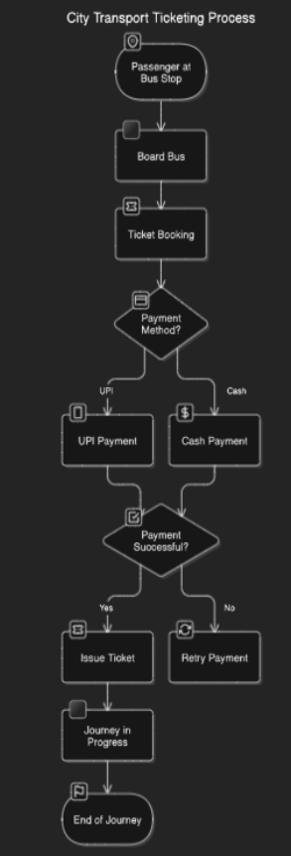

## 6.2 New-Process

• **Passenger selects a route**: The passenger opens the transport app, selects the route they want to travel, and checks the available buses.

• **Ticket booking**: The passenger enters payment details, books the ticket, and receives a digital ticket.

• **Ticket validation**: Upon boarding, the bus conductor verifies the ticket using a physical or manual system.

• **Real-time tracking**: The app shows the current live location of buses, allowing passengers to track their journey.

• **End of journey**: After reaching the destination, the journey is completed, and the ticket is marked as used or expired in the system.

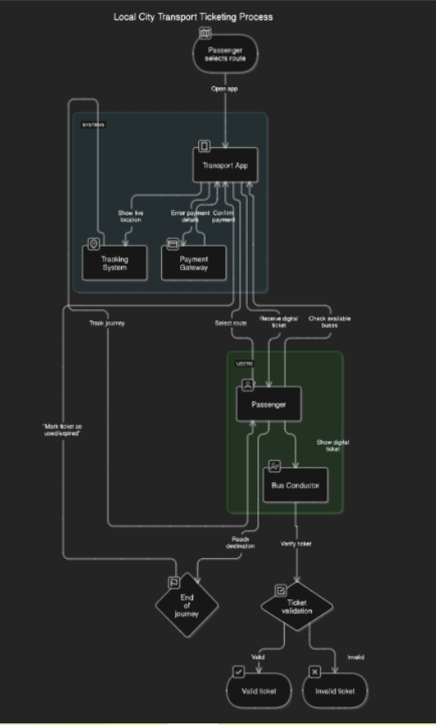

# **System Requirements**

#### **7.1** Functional Requirements

**1.1 User Authentication and Registration**

* Users must be able to create an account using their email or through social logins (Google, Facebook, etc.).
* The system must authenticate users securely and allow login/logout functionality.

**1.2 Ticket Booking**

* Users must be able to book tickets for specific routes and times.
* The system should display available routes, bus timings, and ticket options.
* Users should be able to select their preferred travel date and time.
* The system must generate a live, valid ticket for the user with a unique QR code and a green validation symbol.

**1.3 Real-time Bus Tracking**

* The app must provide real-time bus location data on a map, based on the selected route.
* Users should be able to track buses in real-time to monitor the progress of their journey.

**1.4 Payment Integration**

* Users should be able to pay for their tickets through various payment methods (credit/debit cards, mobile wallets).
* The system must securely handle payment processing and provide confirmation once the payment is successful.

**1.5 Ticket Validation**

* The system must validate the user’s ticket by checking the QR code or digital validation symbol for authenticity.
* Bus conductors should be able to scan the QR code to validate the active ticket.

**1.6 Notifications**

* The app must send push notifications to users for updates on ticket booking, bus arrival, or any system changes.

**1.7 User Profile and History**

* Users must be able to view their booking history and profile details.
* The system should allow users to update their profile information (e.g., name, payment methods, etc.).

#### **7.2.** Non-Functional Requirements

**2.1 Performance Requirements**

* The app should load all ticketing information, including routes and schedules, within **5 seconds**.
* The real-time bus tracking map should update at least every **30 seconds** without performance degradation.
* The system should handle a high number of concurrent users during peak usage without performance issues.

**2.2 Security Requirements**

* All personal and payment data must be encrypted using SSL/TLS during transmission.
* The app must comply with data protection regulations (e.g., GDPR) to ensure user privacy.
* Payment transactions must be secured by integrating with trusted payment gateways that follow industry standards.
* Users must authenticate securely using methods like multi-factor authentication (MFA), if necessary.

**2.3 Usability and Accessibility**

* The app must have an intuitive and user-friendly interface, allowing even non-tech-savvy users to navigate effortlessly.
* The app must adhere to accessibility standards to ensure usability by people with disabilities (e.g., screen reader support, color contrast adjustments).

**2.4 Scalability**

* The system must be designed to scale with increasing users, bookings, and traffic. The architecture should support adding new cities or transport routes without major rework.
* Load balancing mechanisms should be implemented to distribute traffic evenly across servers, ensuring system stability during high-demand periods.

**2.5 Availability and Reliability**

* The system should be available **99.9%** of the time, with minimal downtime for maintenance.
* The app should support automatic failover mechanisms to ensure continuity in case of server failure.

**2.6 Compatibility**

* The app should be compatible with Android (version 8.0 or above) and iOS (version 12.0 or above) devices.
* The app should support both Wi-Fi and mobile data connections, with offline capabilities for certain features (e.g., viewing previously loaded ticket information).

**2.7 Maintainability**

* The system should be designed to allow for easy maintenance, including bug fixes, updates, and the addition of new features.
* The app should be modular, allowing for easier updates and extensions without disrupting the existing functionality.

**2.8 Backup and Disaster Recovery**

* The system must have automated backup processes to ensure no loss of critical data (e.g., user accounts, booking details, payment history).
* Disaster recovery mechanisms should be in place to restore the system in the event of a catastrophic failure.

**2.9 Compliance and Regulatory Requirements**

* The system must comply with the local transportation regulations and industry standards, including the necessary certifications for digital ticketing and payment processing.
* The app should meet data protection regulations like GDPR (General Data Protection Regulation) in the regions it operates.

# **8. Other Options To Satisfy The Requirements**

**1. Ticket Booking**

Alternative Option 1: **Web-based Booking**

* **Description**: In addition to the mobile app, a web-based booking platform can be developed, allowing users to book tickets through their browsers.
* **Pros**:
  + Accessible from any device with internet access.
  + Easier to develop for desktop and tablet users.
* **Cons**:
  + Requires users to access the system through a web browser instead of a native app.
  + May not offer the same seamless experience as a mobile app, especially for on-the-go users.

Alternative Option 2: **SMS-based Ticket Booking**

* **Description**: Allow users to book tickets via SMS by sending their route and timing preferences to a dedicated number.
* **Pros**:
  + Simple for users who do not have smartphones or prefer not to use an app.
  + Can be used for wider outreach, including in low-tech areas.
* **Cons**:
  + Limited functionality compared to the mobile app (e.g., no real-time updates or interactive features).
  + Lack of personalized experience.

**2. Real-time Bus Tracking**

Alternative Option 1: **Scheduled Updates Instead of Real-Time Data**

* **Description**: Instead of real-time tracking, the app can display bus locations based on fixed time intervals (e.g., every 5 minutes) or estimated arrival times.
* **Pros**:
  + Easier to implement without requiring continuous GPS tracking data.
  + Reduces dependency on transport authorities for real-time data.
* **Cons**:
  + Less accurate and may lead to user frustration if buses arrive earlier or later than expected.
  + Does not provide up-to-the-minute tracking for real-time decision making.

Alternative Option 2: **Third-Party Bus Tracking Services**

* **Description**: Integrate with third-party services like Google Maps or public transport APIs that already offer real-time tracking data.
* **Pros**:
  + Utilizes existing services to reduce development time and complexity.
  + Already has established infrastructure and accuracy.
* **Cons**:
  + Dependent on third-party service availability and potential service disruptions.
  + May not provide complete control over the data quality or updates.

**3. Payment Integration**

Alternative Option 1: **In-App Mobile Wallets (e.g., Apple Pay, Google Pay)**

* **Description**: Integrate in-app payment systems like Apple Pay, Google Pay, or other mobile wallets, allowing users to make seamless payments directly within the app.
* **Pros**:
  + Quick, secure, and easy for users, improving the user experience.
  + Reduces the need for entering payment details each time.
* **Cons**:
  + Requires integration with specific mobile wallet services.
  + May limit availability for users without compatible devices or services.

Alternative Option 2: **Direct Bank Transfers**

* **Description**: Offer users the option to make ticket payments via direct bank transfers or through a banking API (e.g., ACH payments).
* **Pros**:
  + Direct connection to users’ bank accounts, potentially reducing transaction fees.
  + Suitable for regions where mobile wallet adoption is low.
* **Cons**:
  + Slower payment processing times (may take hours or days).
  + Less user-friendly and more complex for quick, on-the-go purchases.

**4. Ticket Validation**

Alternative Option 1: **SMS Ticket Verification**

* **Description**: Send users a confirmation SMS with a unique code upon booking, which can be verified by conductors using the app or a simple SMS-based system.
* **Pros**:
  + Simple and inexpensive alternative to QR codes or digital validation.
  + Easily accessible by all users, even without smartphones.
* **Cons**:
  + Less secure than QR codes or digital validation symbols.
  + Can lead to delays or user confusion if the SMS is delayed or not received.

Alternative Option 2: **RFID-enabled Tickets**

* **Description**: Use Radio Frequency Identification (RFID) technology to issue physical tickets with embedded chips or cards. Conductors can scan these cards for validation.
* **Pros**:
  + High level of security and fast validation process.
  + Works well in environments where users may not have smartphones.
* **Cons**:
  + Additional hardware and infrastructure required for both users and conductors.
  + Less flexible and more expensive compared to digital solutions like QR codes.

**5. Scalability and Backend Infrastructure**

Alternative Option 1: **On-Premise Infrastructure**

* **Description**: Host the backend systems on-premise, using dedicated servers and hardware owned and managed by the organization.
* **Pros**:
  + Full control over the infrastructure and data security.
  + Can be tailored to the specific needs of the application.
* **Cons**:
  + Expensive to maintain, especially with high traffic and scaling needs.
  + Requires dedicated IT resources for upkeep and monitoring.

Alternative Option 2: **Cloud-based Infrastructure (e.g., AWS, Google Cloud, Azure)**

* **Description**: Use cloud service providers to host the backend infrastructure and scale according to demand.
* **Pros**:
  + Scalable on-demand, with the ability to handle spikes in traffic.
  + Cost-effective, as you pay only for the resources used.
  + Easier to implement and manage with lower upfront costs.
* **Cons**:
  + Dependency on third-party cloud services.
  + Security concerns related to storing data on external platforms, though mitigated through encryption and compliance.

**6. User Experience and Accessibility**

Alternative Option 1: **Native Mobile Apps for Each Platform (iOS and Android)**

* **Description**: Develop separate native apps for iOS and Android to ensure a fully optimized user experience for each platform.
* **Pros**:
  + Fully optimized for each platform, ensuring the best possible performance and UI.
  + Access to platform-specific features (e.g., push notifications, biometric authentication).
* **Cons**:
  + More development time and effort for maintaining two separate codebases.
  + Higher costs for development and testing.

Alternative Option 2: **Cross-Platform Development (e.g., React Native, Flutter)**

* **Description**: Develop the app using a cross-platform framework, allowing one codebase to run on both iOS and Android.
* **Pros**:
  + Faster development cycle and cost savings.
  + Easier to maintain and update one unified codebase.
* **Cons**:
  + Performance may not be as optimized as native apps, particularly for complex features.
  + Limited access to some platform-specific features and native APIs.

**7. Compliance and Regulatory Approvals**

Alternative Option 1: **Outsource Legal and Compliance Management**

* **Description**: Hire external legal advisors or compliance consultants to handle regulatory requirements and ensure compliance with data privacy and security laws.
* **Pros**:
  + Expertise in navigating complex legal landscapes.
  + Allows the internal team to focus on development and operations.
* **Cons**:
  + Additional costs for external services.
  + Potential delays in obtaining legal approvals due to external dependencies.

Alternative Option 2: **In-House Legal and Compliance Team**

* **Description**: Set up an internal team or hire personnel to manage regulatory approvals, compliance audits, and legal processes.
* **Pros**:
  + Full control over compliance and regulatory management.
  + Quick response time to regulatory changes.
* **Cons**:
  + Requires investment in hiring and training staff with specialized legal expertise.
  + Can be time-consuming to establish and maintain an in-house team.

# **Definition Of Completion**

Will be determined in future Requirements Document and / or future Technical Specification Document.

# **User Stories Summary**

**1. User Registration and Authentication**

* **User Story 1.1**: As a new user, I want to register with my email and password so that I can create an account to book tickets and track buses.
* **Acceptance Criteria**:
  + The user can register using email/password or social login (Google, Facebook).
  + User is redirected to the home screen after successful registration.
* **User Story 1.2**: As a returning user, I want to log in with my credentials so that I can access my previous bookings and preferences.
* **Acceptance Criteria**:
  + Users can log in using their email/password or social login.
  + User credentials are securely validated and authenticated.

**2. Ticket Booking**

* **User Story 2.1**: As a user, I want to search for available bus routes and select a route so that I can book a ticket for my journey.
* **Acceptance Criteria**:
  + The app shows a list of available routes based on the user’s location and destination.
  + The user can select the preferred route and view available times.
* **User Story 2.2**: As a user, I want to select a bus departure time and confirm my booking so that I can purchase a ticket for my trip.
* **Acceptance Criteria**:
  + The user can select the time for the bus journey and proceed to payment.
  + The user receives a booking confirmation and ticket.

**3. Payment Processing**

* **User Story 3.1**: As a user, I want to pay for my bus ticket using a secure payment gateway (credit card, mobile wallet) so that I can complete the booking process.
* **Acceptance Criteria**:
  + The app supports multiple payment methods (credit card, Google Pay, Apple Pay, etc.).
  + Payment is securely processed, and the user receives a payment confirmation.
* **User Story 3.2**: As a user, I want to receive a digital ticket with a green validation symbol once I’ve completed my payment so that I have proof of my active ticket.
* **Acceptance Criteria**:
  + The user receives a digital ticket with a unique QR code or validation symbol.
  + The ticket is stored in the user's profile for easy access.

**4. Real-Time Bus Tracking**

* **User Story 4.1**: As a user, I want to view real-time bus locations on the map so that I can track my bus’s arrival and adjust my plans accordingly.
* **Acceptance Criteria**:
  + The app displays real-time bus locations on an interactive map.
  + The app updates bus positions at regular intervals to reflect accurate location data.
* **User Story 4.2**: As a user, I want to receive notifications when my bus is arriving so that I can be ready to board on time.
* **Acceptance Criteria**:
  + Users receive push notifications when their selected bus is within a certain distance or approaching the scheduled stop.

**5. Ticket Validation**

* **User Story 5.1**: As a bus conductor, I want to scan the user’s QR code or view their validation symbol to verify the ticket is valid and active for travel.
* **Acceptance Criteria**:
  + Conductors can scan QR codes or visually check the digital ticket for a green validation symbol.
  + The app validates the ticket in real-time and confirms its status.
* **User Story 5.2**: As a bus conductor, I want to view the user’s journey details and booking information so that I can verify their ticket against the correct route and date.
* **Acceptance Criteria**:
  + The conductor can access ticket details such as route, time, and passenger details from the app’s ticket validation interface.

**6. User Profile Management**

* **User Story 6.1**: As a user, I want to view and manage my personal details, payment methods, and previous bookings so that I can update my information as needed.
* **Acceptance Criteria**:
  + The user can access and update their profile details.
  + Previous bookings are displayed, and users can view or cancel their tickets.
* **User Story 6.2**: As a user, I want to receive personalized notifications or reminders for upcoming journeys so that I can stay informed about my travel plans.
* **Acceptance Criteria**:
  + The app sends push notifications or reminders about upcoming bookings, schedule changes, or bus delays.

**7. System Notifications and Alerts**

* **User Story 7.1**: As a user, I want to receive alerts for schedule changes, delays, or cancellations so that I can adjust my travel plans.
* **Acceptance Criteria**:
  + The app sends push notifications about any changes to the bus schedule.
  + The user can acknowledge or dismiss the notification.
* **User Story 7.2**: As a user, I want to be alerted when my bus is near my current location so that I can prepare for boarding.
* **Acceptance Criteria**:
  + Users receive a notification when their bus is 5 minutes away from their current location or stop.

**8. User Feedback and Support**

* **User Story 8.1**: As a user, I want to provide feedback on my experience using the app so that I can help improve the service.
* **Acceptance Criteria**:
  + The user can rate their journey and provide feedback about their experience.
  + Feedback is stored and accessible for the development and support teams.
* **User Story 8.2**: As a user, I want to contact customer support in case of issues with booking, payment, or the app so that I can receive assistance promptly.
* **Acceptance Criteria**:
  + The user can access a support interface with options to call, email, or chat with customer support.

# **Impact Urgency**

**1. User Registration and Authentication**

* **Impact**: High
  + Critical for user access and engagement. Without proper registration and authentication, users cannot use the app, which is essential for the app's functionality.
* **Urgency**: High
  + This feature must be implemented early in the project to ensure users can register and log in to use the app. Delays could prevent the app from being usable.

**2. Ticket Booking System**

* **Impact**: High
  + Booking tickets is the core functionality of the app. If users cannot book tickets, the primary business goal of enabling online ticketing for transport services will fail.
* **Urgency**: High
  + This feature is critical to the app's primary purpose. It should be developed early, tested thoroughly, and made available as soon as possible.

**3. Real-Time Bus Tracking**

* **Impact**: High
  + Real-time bus tracking provides immense value to users by helping them plan their journey. It directly impacts the user experience and the app’s overall usefulness.
* **Urgency**: Medium
  + While real-time tracking is highly beneficial, it may not be essential for the first release. It can be introduced in phases, starting with basic functionality and enhancing it later.

**4. Payment Processing Integration**

* **Impact**: High
  + Secure and smooth payment processing is critical for the app’s success, enabling users to pay for tickets and ensuring financial transactions are handled properly.
* **Urgency**: High
  + Payment integration must be implemented before the ticket booking system is fully operational. Delays here could hinder the ticket purchase process and affect user trust.

**5. Ticket Validation (QR Codes or Digital Validation)**

* **Impact**: High
  + Ticket validation is essential for conductors to confirm ticket authenticity and for users to ensure they are traveling with valid tickets. Without it, the bus system cannot operate effectively.
* **Urgency**: High
  + This feature is crucial for operationalizing the ticketing system. It must be part of the app’s core functionality to ensure smooth operations when users start traveling.

**6. User Profile Management**

* **Impact**: Medium
  + Managing user profiles allows for a personalized experience and better user retention. However, it is secondary to the core functionalities (ticket booking and payment).
* **Urgency**: Medium
  + This can be developed iteratively and does not need to be fully available in the first version of the app. However, it should be implemented in the early stages to support user interaction and preferences.

**7. Notifications and Alerts**

* **Impact**: Medium
  + Notifications enhance the user experience by providing real-time updates about bus arrival times and changes. While helpful, it is not critical to the basic functionality of the app.
* **Urgency**: Medium
  + While useful for improving user engagement, notifications can be added later in the development cycle after core features like ticket booking and payment are functional.

**8. Feedback and Customer Support**

* **Impact**: Medium
  + User feedback and support systems are important for maintaining customer satisfaction and addressing issues. However, they are not required for the core app experience to work.
* **Urgency**: Low
  + While important for long-term user retention, this feature can be deferred to a later phase in development, especially when focusing on ticketing and tracking functionalities.

**Summary of Impact Urgency**

| **Feature** | **Impact** | **Urgency** |
| --- | --- | --- |
| **User Registration and Authentication** | High | High |
| **Ticket Booking System** | High | High |
| **Real-Time Bus Tracking** | High | Medium |
| **Payment Processing Integration** | High | High |
| **Ticket Validation (QR Codes)** | High | High |
| **User Profile Management** | Medium | Medium |
| **Notifications and Alerts** | Medium | Medium |
| **Feedback and Customer Support** | Medium | Low |

# **Approvals**

**1. Stakeholder Approval**

* **Approval by Client (PMC)**:
  + **Purpose**: The client (PMC) must review and approve the BRD to ensure that all their business objectives, goals, and requirements have been captured accurately. This ensures alignment between the business needs and the app’s development.
  + **Responsible Party**: Project Manager, Business Analyst, Client Representatives.

**2. Technical Team Approval**

* **Approval by Development Team**:
  + **Purpose**: The development team must review the BRD to ensure that the functional and technical requirements are feasible, clear, and align with the capabilities of the proposed technology stack. This helps identify potential challenges early on.
  + **Responsible Party**: Lead Developer, Technical Architect, DevOps Team.

**3. Legal and Compliance Approval**

* **Approval by Legal Team**:
  + **Purpose**: The legal team must review the document to ensure that the mobile app complies with data privacy laws (e.g., GDPR, CCPA), payment regulations, and transport regulations. This approval is crucial for ensuring that the app does not violate any legal or regulatory requirements.
  + **Responsible Party**: Legal Counsel, Compliance Officer.

**4. Design and User Experience Approval**

* **Approval by UX/UI Design Team**:
  + **Purpose**: The design team needs to review the BRD to ensure that the user interface and experience align with the defined business requirements. This ensures that the user journey, visual design, and accessibility considerations are integrated into the app's development.
  + **Responsible Party**: UX/UI Designer, Design Lead.

**5. Transport Authorities Approval**

* **Approval by Transport Authorities (City Transit)**:
  + **Purpose**: Since the app integrates with real-time bus data and the booking system for city transport, approval from the relevant local transport authorities is required to ensure data access and integration are permitted. This includes access to GPS data, bus schedules, and any legal agreements on the use of this information.
  + **Responsible Party**: Transport Authority Representatives, Public Transit Operations.

**6. Payment Gateway Approval**

* **Approval by Payment Gateway Providers**:
  + **Purpose**: If the app integrates with third-party payment systems (e.g., Stripe, PayPal), approval from the payment gateway providers is necessary to ensure the integration is feasible, secure, and compliant with payment regulations (PCI-DSS).
  + **Responsible Party**: Payment Integration Specialist, Payment Gateway Account Manager.

**7. Quality Assurance Approval**

* **Approval by QA Team**:
  + **Purpose**: The Quality Assurance (QA) team must ensure that the BRD outlines clear testable requirements for the app. This approval confirms that all functional and non-functional requirements are aligned with the app’s quality standards.
  + **Responsible Party**: QA Lead, Testers, Quality Assurance Manager.

**8. Security Team Approval**

* **Approval by Security Team**:
  + **Purpose**: The security team needs to review the BRD for any potential security vulnerabilities, particularly related to user data privacy, payment processing, and real-time data integration. Their approval ensures that security measures are in place to protect user data and prevent breaches.
  + **Responsible Party**: Security Officer, Security Architect.

**9. Regulatory Approval**

* **Approval by Regulatory Bodies**:
  + **Purpose**: Depending on the jurisdiction, regulatory bodies may need to approve the mobile app, especially regarding user data protection, digital payment systems, and transportation-related regulations (e.g., city transport laws). This approval ensures the app meets all necessary regulatory requirements.
  + **Responsible Party**: Regulatory Compliance Officer, External Auditors (if applicable).

**10. Project Sponsor or Executive Approval**

* **Approval by Project Sponsor or Executive Team**:
  + **Purpose**: The executive team or project sponsor, who holds responsibility for the overall success and budget of the project, needs to approve the BRD to ensure that the business objectives are aligned with the company’s strategic vision and goals.
  + **Responsible Party**: Project Sponsor, Senior Leadership Team.

**Summary of Required Approvals**

| **Approval Required** | **Purpose** | **Responsible Party** |
| --- | --- | --- |
| **Stakeholder Approval** | Ensure alignment with business needs | Client (PMC), Project Manager, Business Analyst |
| **Technical Team Approval** | Confirm technical feasibility and alignment with tech stack | Development Team, Technical Architect, DevOps Team |
| **Legal and Compliance Approval** | Ensure compliance with legal and regulatory requirements | Legal Counsel, Compliance Officer |
| **Design and UX Approval** | Ensure UI/UX alignment with requirements | UX/UI Design Team |
| **Transport Authorities Approval** | Obtain permission to access transport data and services | Transport Authority Representatives |
| **Payment Gateway Approval** | Confirm integration feasibility and compliance | Payment Gateway Providers |
| **Quality Assurance Approval** | Validate testability and quality standards | QA Lead, QA Team |
| **Security Team Approval** | Ensure security measures are in place | Security Officer, Security Architect |
| **Regulatory Approval** | Ensure regulatory compliance (data privacy, transport laws) | Regulatory Bodies, Compliance Officer |
| **Project Sponsor/Executive Approval** | Confirm strategic alignment and budget approval | Project Sponsor, Senior Leadership |